HW04
Due on April 11, 2024 by 11:59 PM
William Wenzel
Problem 1 RL (10pts)
(a) Identify the proper RL plot for feedback control design for the plant with:
$$G\left(s\right)=\frac{s}{s^{2}+2s+4}$$
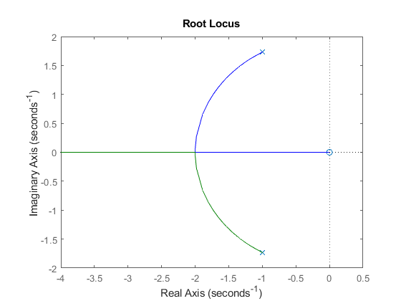
(b) For a plant G(s) with RL plot given below, please determine:
- Poles of the plant: _-5, -1______
- Zeros of the plant: _-1+/- j1.75_
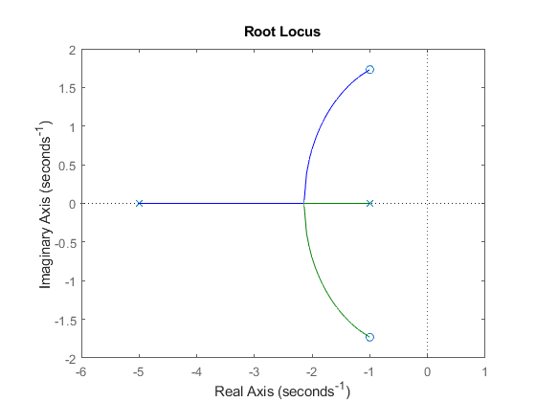

Problem 2 PID feedback control design (40pts)
- The following PI controller has been applied to the DC motor given by $G\left(s\right)=\frac{1}{Js^{2}+cs}$ with J=1, c=4:
$$H\left(s\right)=\frac{K_{i}}{s}+K_{p}$$

$$\begin{aligned}T_{\text{closed}}\left(s\right)=\frac{G\left(s\right)H\left(s\right)}{1+G\left(s\right)H\left(s\right)}\#Eq. 1.1\end{aligned}$$
$$\begin{aligned}T_{\text{closed}}\left(s\right)=\frac{\frac{K_{i}}{s\left(s^{2}+4s\right)}+\frac{K_{p}}{s^{2}+4s}}{1+\frac{K_{i}}{s\left(s^{2}+4s\right)}+\frac{K_{p}}{s^{2}+4s}}\#Eq. 1.2\end{aligned}$$
$$\begin{aligned}T_{\text{closed}}\left(s\right)=\frac{s}{s^{3}+4s^{2}+K_{p}s+K_{i}}\#Eq. 1.3\end{aligned}$$

To find the stability of the system, we use Routh Criterion

$$\begin{aligned}\begin{matrix}s_{1} & 1 & K_{p} \\ s_{2} & 4 & K_{i} \\ s_{3} & \frac{4K_{p}-K_{i}}{4} & \\ s_{4} & \frac{\frac{4K_{p}-K_{i}}{4}*K_{i}-4*0}{\frac{4K_{p}-K_{i}}{4}} & \end{matrix} \#Eq. 1.4\end{aligned}$$

$$\begin{aligned}\begin{matrix}s_{1} & 1 & K_{p} \\ s_{2} & 4 & K_{i} \\ s_{3} & K_{p}-0.25K_{i} & \\ s_{4} & K_{i} & \end{matrix} \#Eq. 1.5\end{aligned}$$

To maintain stability, the left-most column must not change signs, thus,
$$\begin{aligned}K_{p}-0.25K_{i}≥0, AND K_{i}≥0 \#Eq. 1.6\end{aligned}$$
$$\begin{aligned}\frac{K_{p}}{K_{i}}≥0.25, AND K_{i}≥0 \#Eq. 1.7\end{aligned}$$
The System response to a step input is:
$$\begin{aligned}e_{ss}=\frac{1}{1+K_{p}} \#Eq. 1.8\end{aligned}$$
$$\begin{aligned}K_{p}=\lim_{s→0}{\frac{K_{p}s+K_{i}}{s\left(s^{2}+4s\right)}}=∞ \#Eq. 1.9\end{aligned}$$
$$\begin{aligned}e_{ss}=\frac{1}{1+∞}=0 \#Eq. 1.10\end{aligned}$$

- The following PI controller has been applied to a 1st order system given by $G\left(s\right)=\frac{1}{2s+1}$:
$$H\left(s\right)=\frac{K_{i}}{s}+K_{p}$$
Please evaluate the design with step-by-step hand derivation and reasoning.
- What is the stability requirement of the PI feedback control system?
- Will the feedback system generate desired output in response to a unit step input, i.e. having zero steady state error?
- What is the condition for the controlled system to generate non-oscillatory response?

$$\begin{aligned}T_{\text{closed}}\left(s\right)=\frac{G\left(s\right)H\left(s\right)}{1+G\left(s\right)H\left(s\right)}\#Eq. 2.1\end{aligned}$$
$$\begin{aligned}T_{\text{closed}}\left(s\right)=\frac{\frac{K_{i}}{s\left(2s+1\right)}+\frac{K_{p}}{2s+1}}{1+\frac{K_{i}}{s\left(2s+1\right)}+\frac{K_{p}}{2s+1}}\#Eq. 2.2\end{aligned}$$
$$\begin{aligned}T_{\text{closed}}\left(s\right)=\frac{s}{2s^{2}+K_{p}s+s+K_{i}}\#Eq. 2.3\end{aligned}$$

To find the stability of the system, we use Routh Criterion

$$\begin{aligned}\begin{matrix}s_{1} & 2 & K_{i} \\ s_{2} & K_{p}+1 & 0 \\ s_{3} & K_{i} & \end{matrix} \#Eq. 2.4\end{aligned}$$

To maintain stability, the left-most column must not change signs, thus,
$$\begin{aligned}K_{p}+1≥0, AND K_{i}≥0\#Eq. 2.5\end{aligned}$$
$$\begin{aligned}K_{p}≥-1, AND K_{i}≥0 \#Eq. 2.6\end{aligned}$$
The System response to a step input is:
$$\begin{aligned}e_{ss}=\frac{1}{1+K_{p}} \#Eq. 2.7\end{aligned}$$
$$\begin{aligned}K_{p}=∞ \#Eq. 2.8\end{aligned}$$
$$\begin{aligned}e_{ss}=\frac{1}{1+∞}=0 \#Eq. 2.9\end{aligned}$$

Non oscillatory response
$$\begin{aligned}2s^{2}+\left(K_{p}+1\right)s+K_{i}=0 \#Eq. 2.10\end{aligned}$$
$$\begin{aligned}Δ={\left(K_{p}+1\right)}^{2}-4*2*K_{i}≥0 \#Eq. 2.11\end{aligned}$$
$$\begin{aligned}{\left(K_{p}+1\right)}^{2}≥8K_{i} \#Eq. 2.12\end{aligned}$$

Problem 3 Sketching Bode plots (15pts)
(a) Consider a 1st order system with $G\left(s\right)=\frac{1}{2s+1}$.
$$G\left(jω\right)=\frac{1}{2jω+1}$$
Find the imaginary and real components of the system:
$$\frac{1}{2jω+1}*\frac{-2jω+1}{-2jω+1}=\frac{-2jω+1}{4ω+1}$$
$$Re→\frac{1}{4ω+1}$$
$$Im→\frac{-2jω}{4ω+1}$$

Gain: $M=\sqrt{Re^{2}+Im^{2}}=\sqrt{{\left(\frac{1}{4ω+1}\right)}^{2}+{\left(\frac{-2jω}{4ω+1}\right)}^{2}}=\sqrt{\frac{1}{{\left(4ω+1\right)}^{2}}+\frac{4ω^{2}}{{\left(4ω+1\right)}^{2}}}=\sqrt{\frac{4ω^{2}+1}{{\left(4ω+1\right)}^{2}}}$

Phase: $ϕ=\tan^{-1}\left(\frac{Im}{Re}\right)=\tan^{-1}\left(\frac{\frac{-2jω}{4ω+1}}{\frac{1}{4ω+1}}\right)=\tan^{-1}\left(-2jω\right)$
$$ω_{c}=0.5 rad/s$$
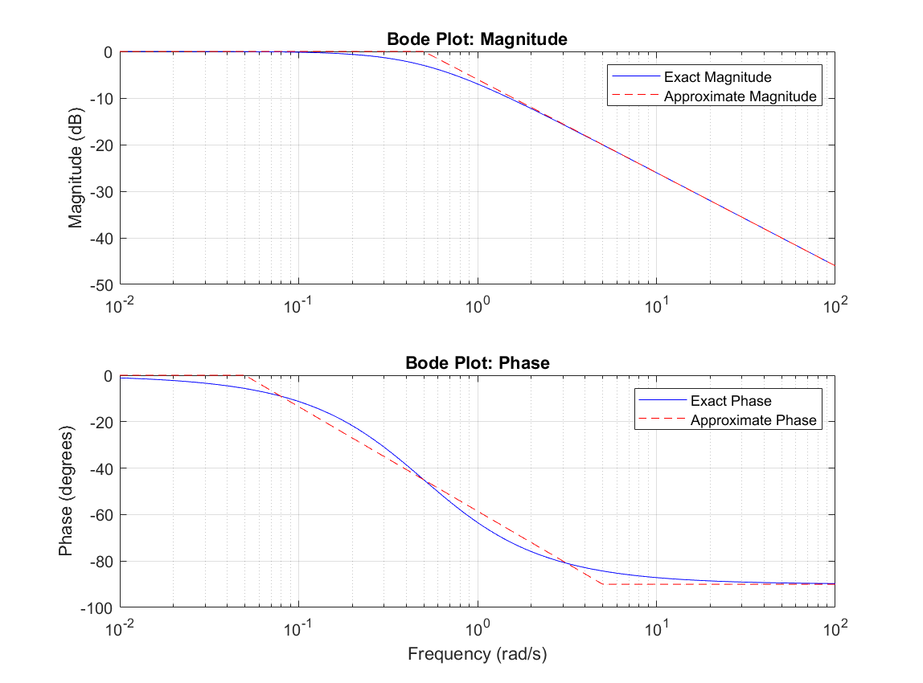

(b) Four cases of Bode plots have been derived and created, as shown in the figure below as A, B, C, D respectively.
Please match the system’s transfer function for each case.
$G_{1}\left(s\right)=\frac{1}{(3s+1)}$ _ C___________
$G_{2}\left(s\right)=\frac{2}{s}$ _ D___________
$G_{3}\left(s\right)=2$ _ A___________
$G_{5}\left(s\right)=\frac{2}{(s^{2}+s+5)}$ _ B___________
(a) | (b)
(c) | (d)

Problem 4 system parameters with Bode plots (10pts)
Note all numbers and tick marks for the horizontal axis $ω$ are decimal though arranged in logarithmic scale. Example:
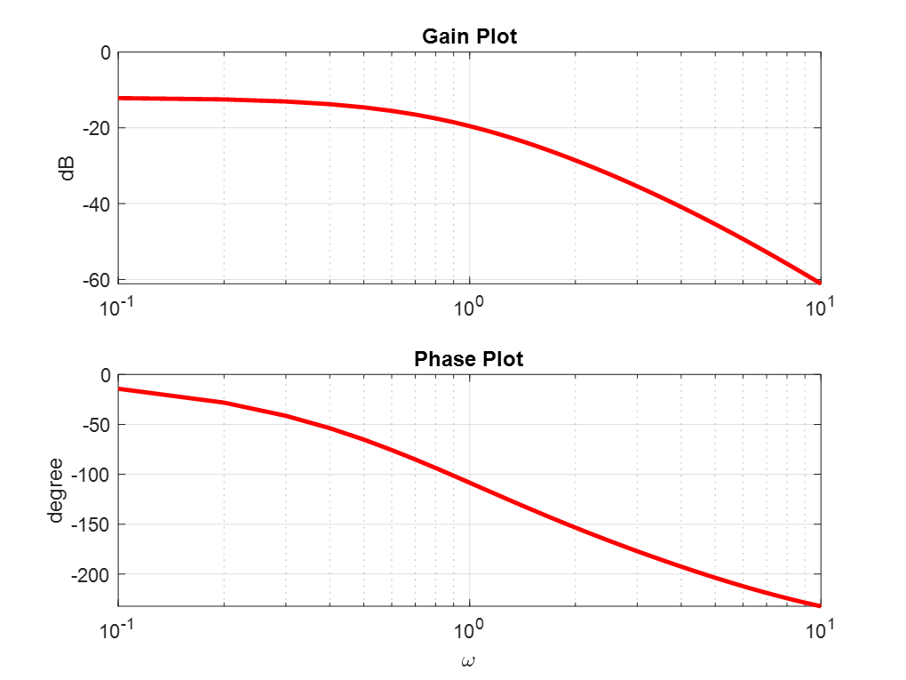
$ω=3$ rad/s
$ω=0.8$ rad/s
$ω=0.9$ rad/s
$ω=2$ rad/s
$ω=1$ rad/s

We have obtained the Gain Bode plots for a 1st or 2nd order system as shown. With the Bode plots, determine the system’s frequency domain parameters. You must indicate in the plots how the results are identified as illustrated in class.

Case (a)
Bandwidth (BW): ___3 rad/s_________

1st __YES____ or 2nd _____ order system? Check your answer.

If 1st order, determine system’s time constant ($τ$): __1/3=0.333______

Case (b)

Bandwidth (BW): _____3 rad/s_______

1st ______ or 2nd _YES____ order system? Check your answer.

If 1st order, determine system’s time constant ($τ$): ___________
If 2nd order, determine system’s natural frequency ($ω_{n}$): __2 rad/s_________

Problem 5 stability analysis with Bode plots (25pts)

(1) The Bode plots of a plant G(s) in a feedback control system are provided.

- Identify the following parameters using the Bode plots. You must indicate in the plots how the results are identified as illustrated in class.

Gain cross-over frequency $ω_{gc}$: __80 rad/s_________

Phase cross-over frequency $ω_{pc}$: ___5.5 rad/s________

Gain margin GM: ___-70 dB________

Phase margin PM: ___-80 degrees________

- Stability analysis:
UNSTABLE

(2) The Bode plots of a plant G(s) in a feedback control system are provided.

- Identify the following parameters using the Bode plots. You must indicate in the plots how the results are identified as illustrated in class.

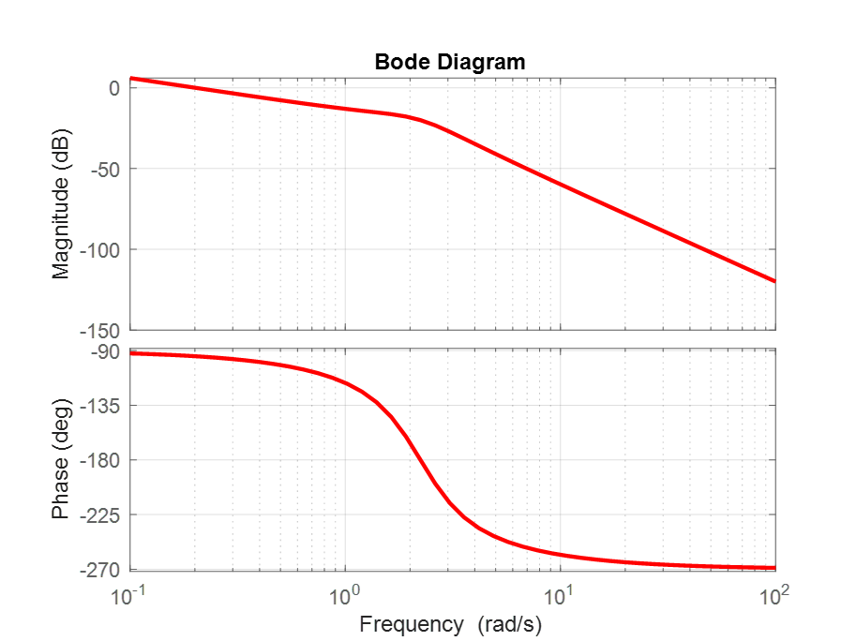

Gain cross-over frequency $ω_{gc}$: __0.2 rad/s _________

Phase cross-over frequency $ω_{pc}$: ___2.2 rad/s________

Gain margin GM: __20 dB_________

Phase margin PM: _____160 deg________

- Stability analysis:
STABLE

- If we would like to make the feedback system with 6 dB Gain margin, how to design it?
Yu would adjust the gain of the system and increase it by 14dB, approx. 0.20 in a linear scale.

